Database System Engineering and Distributed Backend Development(25CS1302E)
DDL,DML,DCL,TCL

Name : K.Dheeraj
Roll No. : 2520030193
SEC : 7
1.DDL COMMANDS : CREATE, ALTER, DROP, TRUNCATE, RENAME :
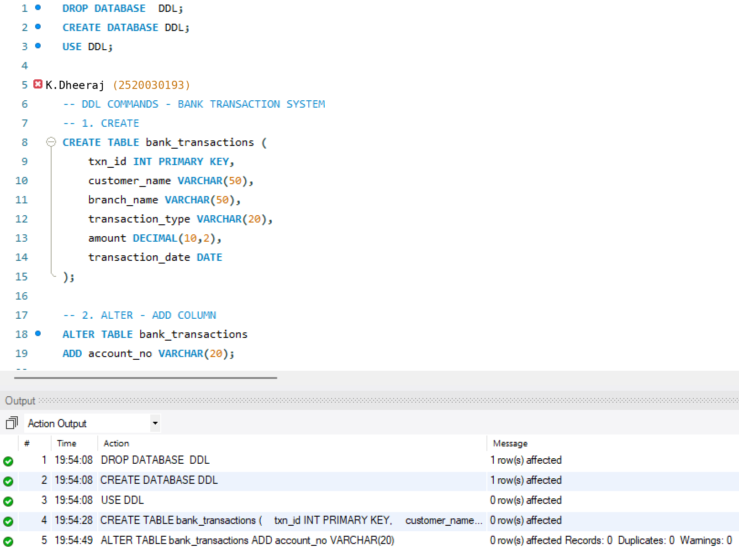
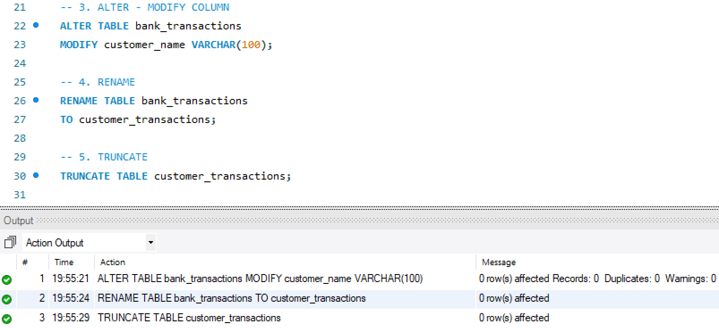
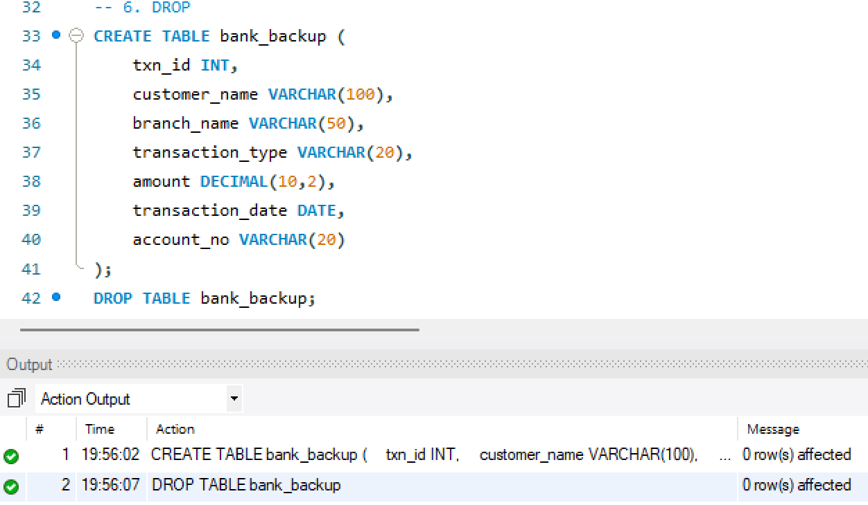

2. DML COMMANDS : INSERT, UPDATE, DELETE, SELECT :
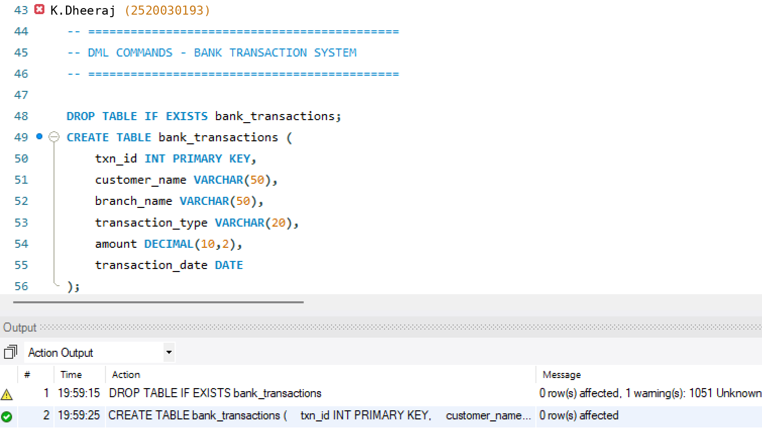
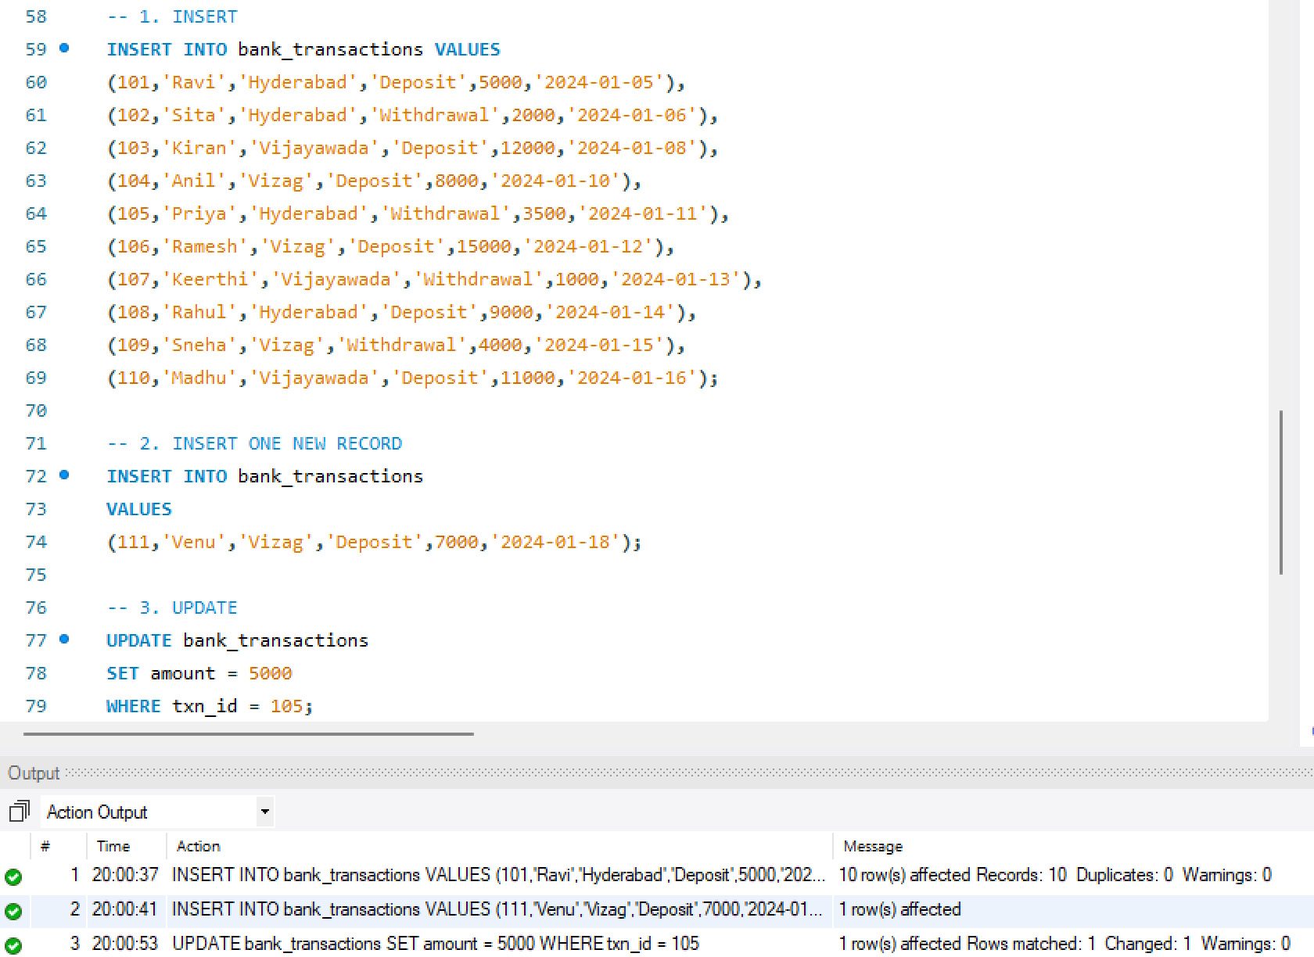
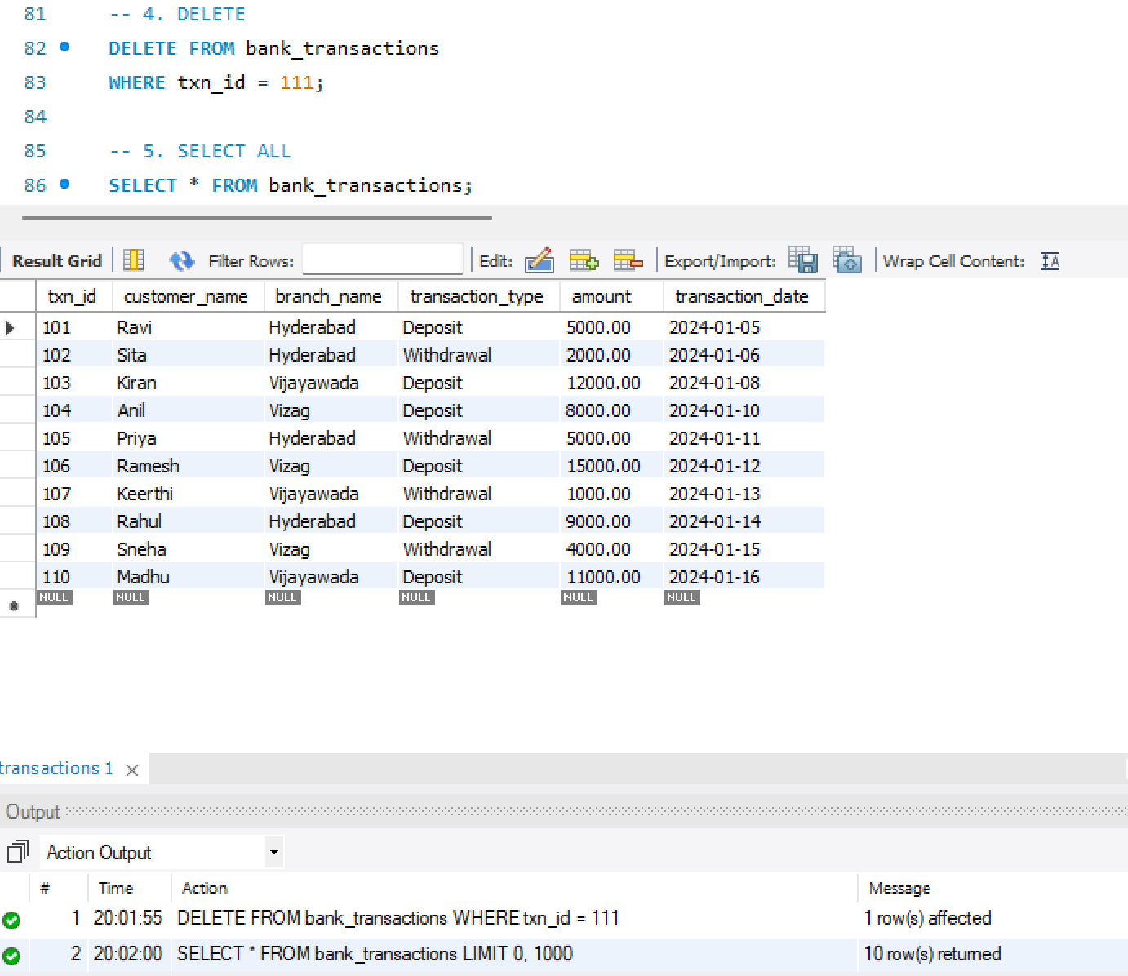
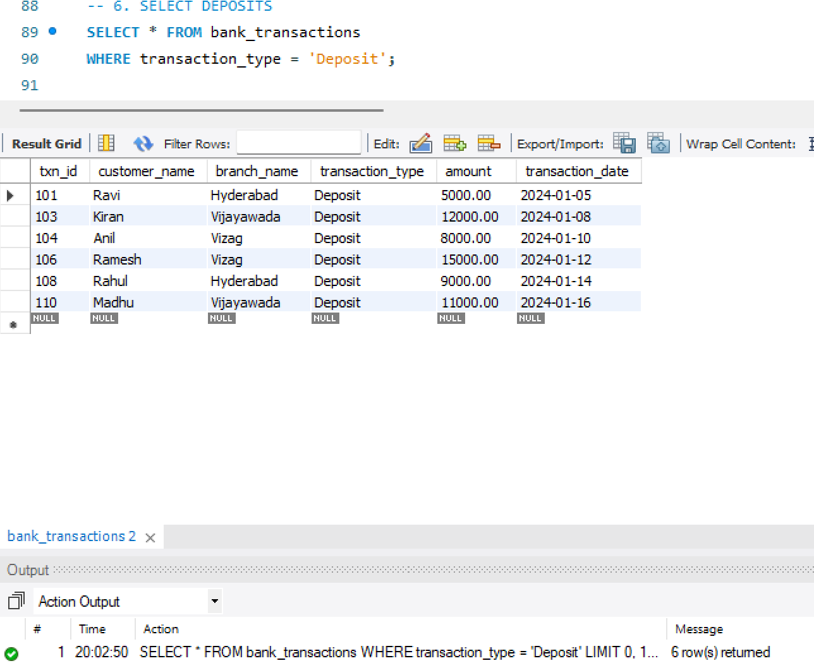
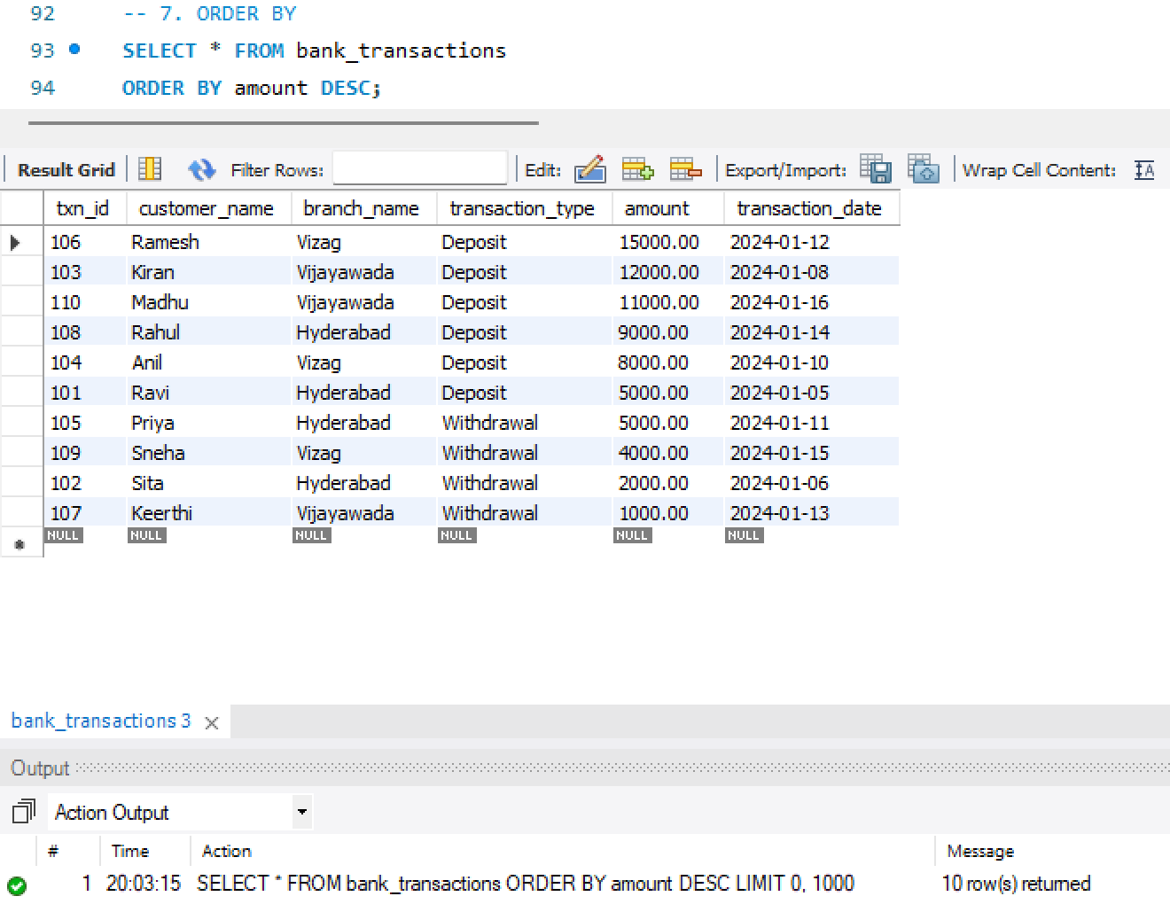
3. DCL COMMANDS : GRANT, REVOKE :
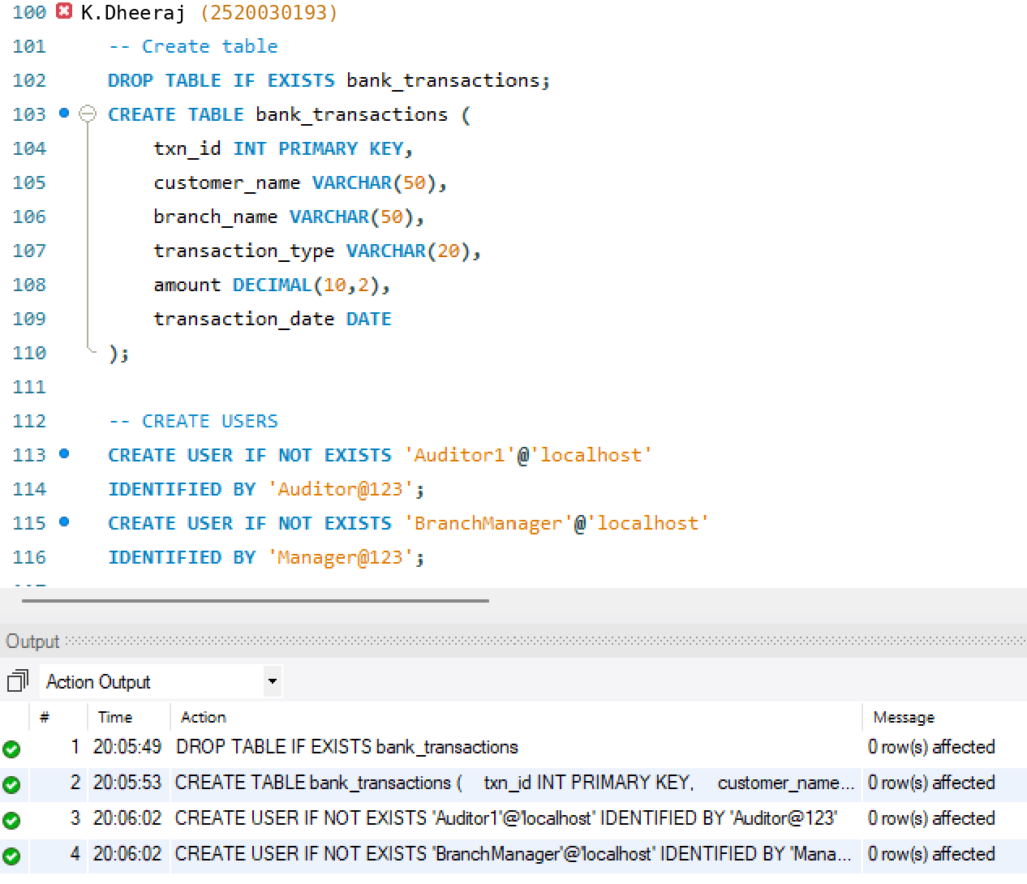
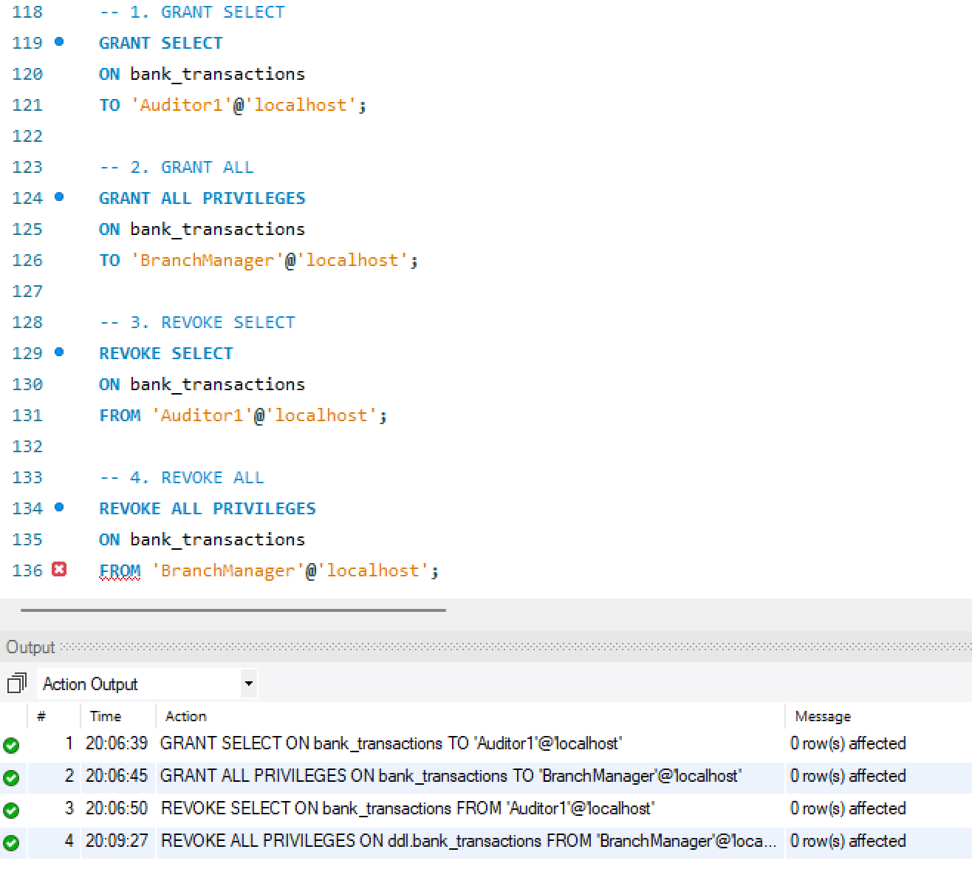

4. TCL COMMANDS : COMMIT, SAVEPOINT, ROLLBACK :
